ACF Lab 6:

Scale and Load Balance your Architecture

____________________________________________________

COS 20019- Cloud Computing Architecture

Nguyen Manh Dung

24/6/2023

**This is all my step to finish ACF Lab 6, with requirements beside the screenshotted.**

**Task 1: Create an AMI for Auto Scaling**

* Select **Web Server 1.**
* In the Actions menu, choose **Image and templates > Create image**, then configure:
  + **Image name**: WebServerAMI
  + **Image** **description**: Lab AMI for Web Server
* Choose **Create image**

**Task 2 : Create a Load Balancer**

* Choose **Create target group**
* Choose a target type: **Instances**
* **Target group name**, enter: LabGroup

**Create load balancer**

* **Load balancer name**, enter: LabELB
* For **VPC**, choose **Lab** **VPC**
* Choose the **first** displayed Availability Zone, then select **Public Subnet 1**
* Choose the **second** displayed Availability Zone, then select **Public Subnet** 2

**Task 3: Create a Launch Template and an Auto Scaling Group**

**Launch template name**: LabConfig

Under **Auto Scaling guidance,** select  *Provide guidance to help me set up a template that I can use with EC2 Auto Scaling*

**Amazon Machine Image (AMI):** choose Web Server AMI

**Instance type**: choose t2.micro

**Key pair name**: choose vockey

**Firewall (security groups):** choose Select existing security group

**Security groups**: choose Web Security Group

Scroll down to the **Advanced details** area and expand it.

Scroll down to **the Detailed CloudWatch monitorin**g setting. Select **Enable**

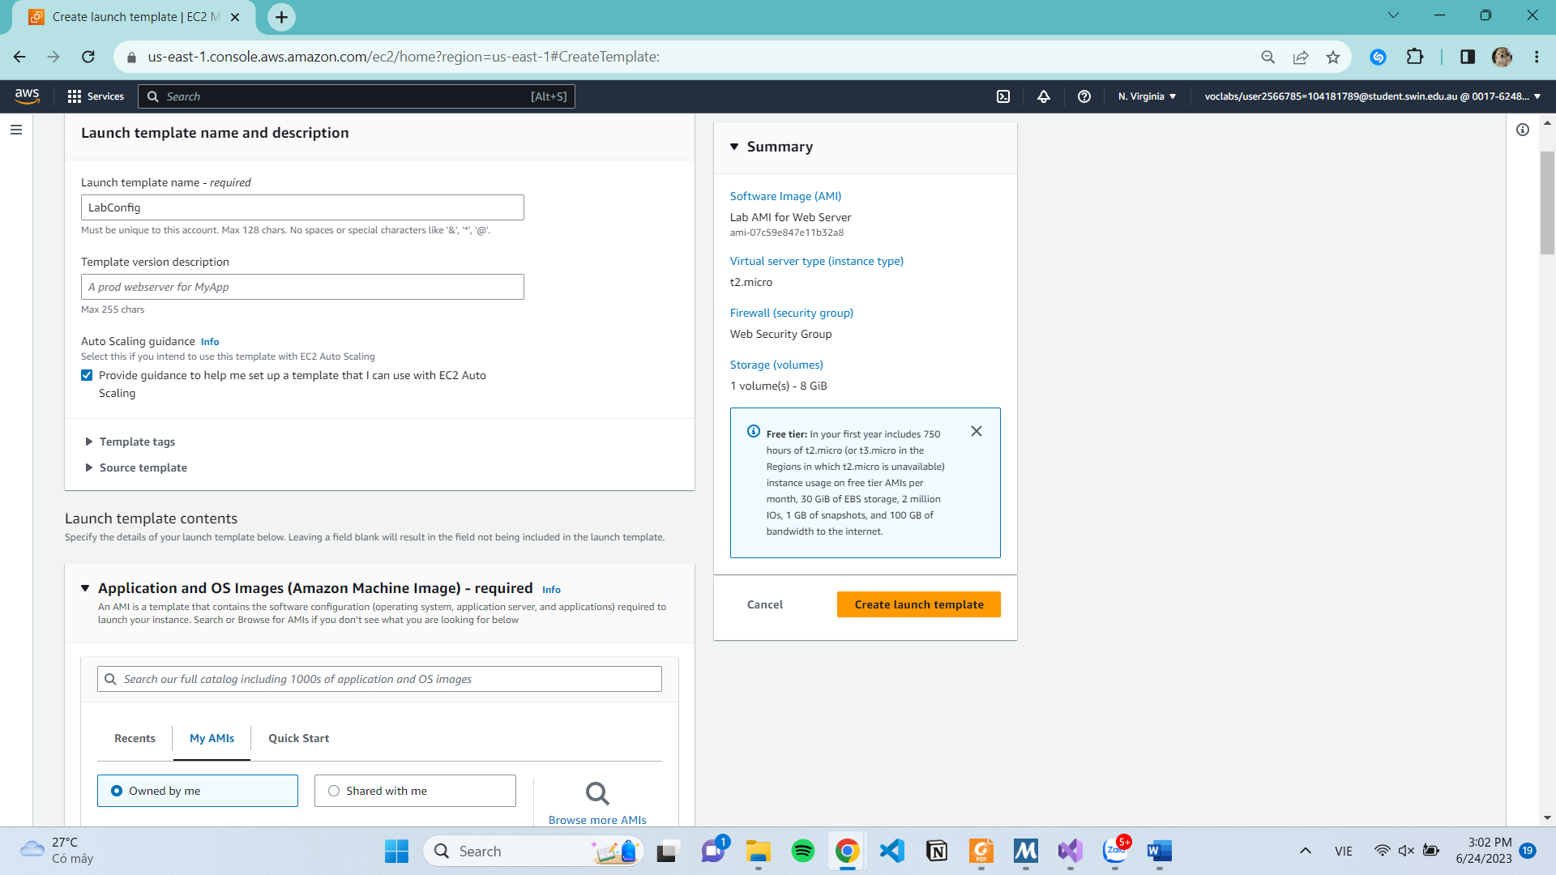

**Create Auto Scaling group**

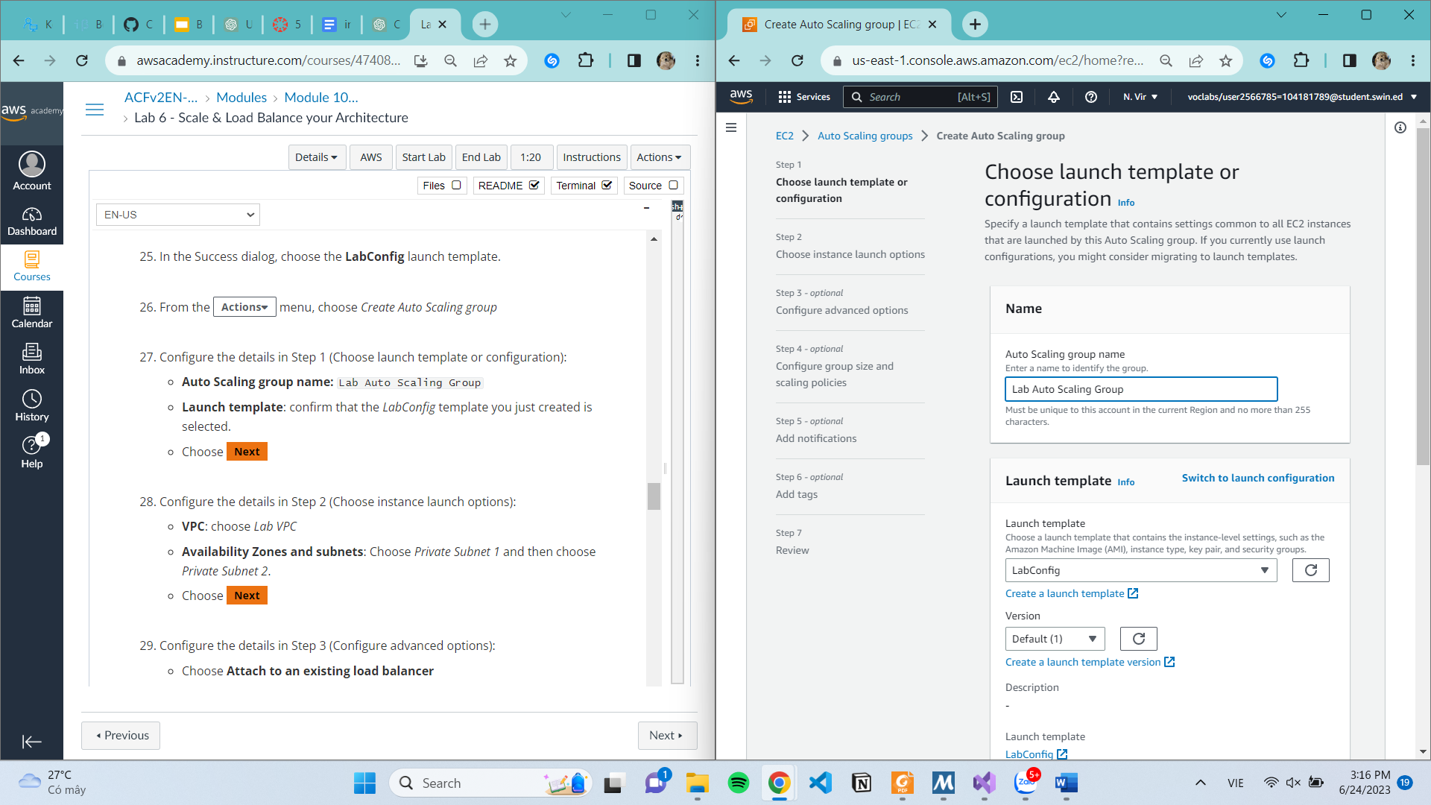

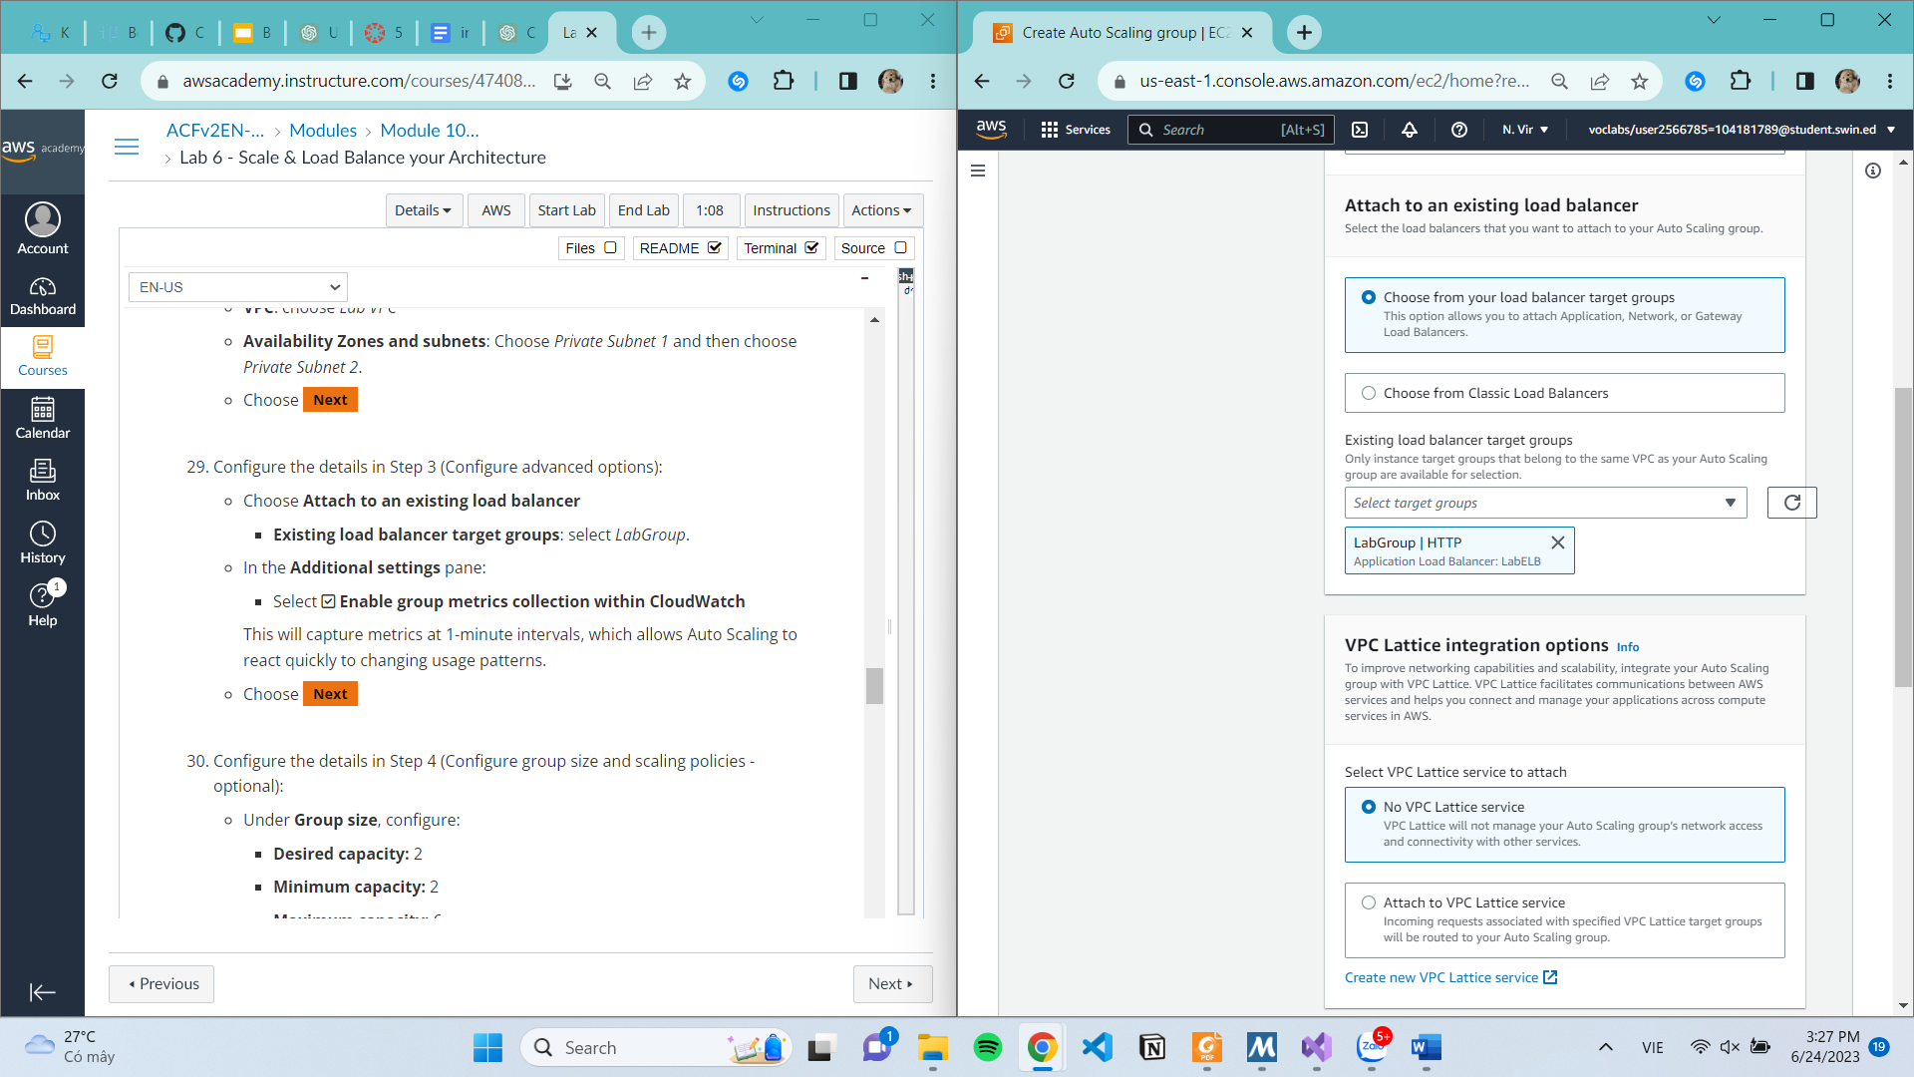

Task 4: Verify that Load Balacing is Working

**Task 5: Test Auto Scaling**

**Task 6: Terminate WebServer 1**

